


PJT03030.R5.SAP.FS.DPP. CRM.ENH.DPP.004 - Enrollment Processes | 

REVIEWER(S)
Name | Title | Department | Reviewed (date/time)
Manoj Ajgaonkar | SAP Solution Architect | SAP |  | <Date / Time>
Jack Hobbick | Testing Solution Manager | Smart Energy Program |  | <Date / Time>
Santhosh Shetty | Testing Lead | HCL |  | <Date / Time>
Jessica Scott | Audit Controls, Deloitte | Deloitte |  | <Date / Time>
Clark Oeler | Audit Controls, Deloitte | Deloitte |  | <Date / Time>
Chaitanya Kodela | BTS SDM Solution Architect | BTS |  | <Date / Time>
Nancy Pierce | Business Support Consultant | Virtual Contact Center |  | <Date / Time>
Abhishek Bansal | SAP Solution Architect | SAP |  | <Date / Time>
Ramesh Swarna | HCL Technical Lead | HCL |  | <Date / Time>
Nilabja Guha | ESB Team Lead | CAP |  | <Date / Time>
John Lalicker | ESB Team | CAP |  | <Date / Time>
Alok Bedi | Grid Director | CAP |  | <Date / Time>
Brent Kassing | iFactor Lead | iFactor |  | <Date / Time>
Jason Iaccio | iFactor Team | iFactor |  | <Date / Time>
Craig Bialy | DRMS Lead | Lockheed Martin |  | <Date / Time>

APPROVER(S)
Name | Title |  | Department |  | Approval (date/time)
Clay Engel |  | Enrollment Vendor Program Manager |  | Smart Energy Program |  | <Date / Time>
Elody Samuelson |  | DPP Program Manager |  | Smart Energy Program |  | <Date / Time>
Krishna Karunakaram |  | Smart Energy Project Manager |  | Smart Energy Program |  | <Date / Time>
Jeff Yankley |  | IT-C&APS-IT App Portfolio-Front Office |  | BTS |  | <Date / Time>
Zach Pakkala |  | Business Support Consultant |  | Customer Operations/SE CORE |  | <Date / Time>
Blair Estep |  | CE Release Manager |  | Smart Energy Program |  | <Date / Time>

CONTRIBUTORS
Name | Organization | Area of Contribution
Sudipto Sinha | Capgemini
Matthew C. Parker | CE
John Lalicker | Capgemini | ESB side clarification

CONTRIBUTORS
Name | Organization | Area of Contribution
Sudipto Sinha | Cap | Document Creation

VERSION HISTORY
Version | Date | Author(s) | Revision Notes
0.1 | 07/27/2015 | Matt Parker | Initial version
0.2 | 10/26/2015 | Ashish Bhargava | Added more details

Table of Contents

REVIEWER(S) 2
APPROVER(S) 2
1 OBJECT REQUIREMENT SUMMARY 5
1.1 Object Information and Attributes 5
1.2 Requirements Summary and Business Driver 6
1.3 Assumptions 7
1.4 Current Functionality 7
1.5 Required Functionality 7
1.6 Project / Development Constraints 7
1.7 Performance Criteria 7
1.8 Other Objects Affected 7
1.9 External References 7
1.10 Definitions/Acronyms/Abbreviations 7
2 ENHANCEMENT DESIGN SPECIFICATIONS 8
2.1 Custom Class 11
2.2 Standard Rule 11
2.3 Custom Table Creation 11
2.4 Work Item Delivery Requirements 11
2.5 Triggering Events Determination 11
2.6 Escalation Requirements 11
2.7 Dependencies 11
2.8 Error Handling Method 11
2.9 Post Execution Notification Details 11
2.10 Process Log Details 11
2.11 Other 12
2.12 Unit Test Plan 12
2.13 Information Security 12
2.14 Audit 12
2.15 Questions / Issues / Risks 12

OBJECT REQUIREMENT SUMMARY

Object Information and Attributes
The following is current information about this object and document:
Object ID | CRM_ENH_DPP_004
Title | PJT03030.R5.SAP.FS.DPP.ENH.004 – Enrollment Processes
Team Which Owns the Object | DPP Enrollment SAP team
System Version | CRM 7.0; ECC 6.0
Development Type | Enhancement
Priority | High
Estimated Complexity | High
Link to Process Flow

Requirements Summary and Business Driver
This functional specification document covers in detail the various DPP Enrollment Processes and sub processes in regards to how the enrollment is initiated and completed in SAP.

Requirement Id for this requirement
Ref. | PRICEFW ID | Enhancement Description
DPP-059; DPP-068; DPP-134; DPP-135 | CRM_ENH_DPP_004 | Ability to identify previous DPP customer at time of Move In and prompt Enrollment initiation.
DPP_145 | CRM_ENH_DPP_009 | An enhancement will present iFactor preference center information to CE Users as part of the DPP Enrollment process, necessitating the addition or update of preferences as needed.

1.2.1 Alternatives to Object
The CE user would have to remember themselves to initiate DPP Enrollment request for the customer, manually investigate to identify if the account is considered eligible for DPP Enrollment.
Additionally, the CE user would have to remember to navigate to the Preference Center in CRM after the completion of a Move In, and update a mandatory preference for the DPP Enrollment.

1.2.2 Impact of Implementation
By implementing these changes, the system will perform an automated basic validation (like Residential customer, Electric Service, and over the air Meter Reading capability) behind the scenes after the completion of a Move In. If the basic checks are successful, the system will display message on email collection screen.

1.2.3 Impact of No Implementation
If not implemented, there would be no automated system prompts in relation to DPP Enrollments. It would be on the user to have to remember to perform the required checks. They would have to manually navigate through the SAP system to perform these validations which would require a great deal of system navigation and increase call handling time.

Assumptions
- CE users that are authorized to perform a move-in or rate change will be authorized to initiate DPP enrollments in SAP, without transferring the call to the EV.
- DPP enrollments can be initiated for both new and existing customers.
- Enrollment Center will be used for the DPP Enrollment and De-Enrollment.

Current Functionality
Currently, no logic exists for DPP Enrollment processes.

Required Functionality
An enhancement is needed in CRM to add functionality to the end of the Move In process to perform a basic check (like Residential customer, Electric Service, and over the air Meter Reading capability) to determine whether or not to prompt the user to access the customer programs Enrollment Center. If the account passes these eligibility checks, a message will be displayed to the Email Collect view “Customer eligible for customer programs, please navigate to the Enrollment Center”.

Project / Development Constraints
None Identified.

Performance Criteria
To be determined in NFR meetings by Business Architecture Team.

Other Objects Affected
None Identified.

External References
None Identified.

Definitions/Acronyms/Abbreviations

EV | Enrollment Vendor
SAP | Systems, Applications & Products in Data Processing
DPP | Dynamic Peak Pricing
CRM | Customer Relationship Management SAP system
CE | Consumers Energy
CSR | Customer Service Representative
IC | Interaction Center

ENHANCEMENT DESIGN SPECIFICATIONS
Enhancement Requirements
Number | Description of Requirement
1 | Creation of new Function Module to check the basic eligibility for Residential Customer, Electric Service and Over the air Meter Reading Capability.
2 | Creation of System Message in CRM prompting Customer Program Enrollment and Navigation to Enrollment Center.
3 | Creation of logic to see if DPP program was selected for Enrollment in the Enrollment Center, navigate the user to the CE Preference Center

Change to existing Move-In Process
In order for users to be able to easily identify customers who are eligible for DPP program enrollment after the completion of any move in in CRM, a new enhancement will be added to perform an automated basic validation (like Residential customer, Electric Service, and over the air Meter Reading capability). This validation should occur prior to displaying the Collect Email view. System will display a message on the Collect Email view “Customer is eligible for customer programs. Please navigate to the Enrollment Center for details”.

Note: CSR will not be allowed to change the product from RS_1000 to RS_1007 or RS_1008 during the move-in. In order to enroll customer; CSR needs to go to Enrollment Center to initiate enrollment.

Verbiage for System Message:
“Customer is eligible for customer programs. Please navigate to the Enrollment Center for details”.

Mock Up of DPP Enrollment Prompt after completion of Move In:

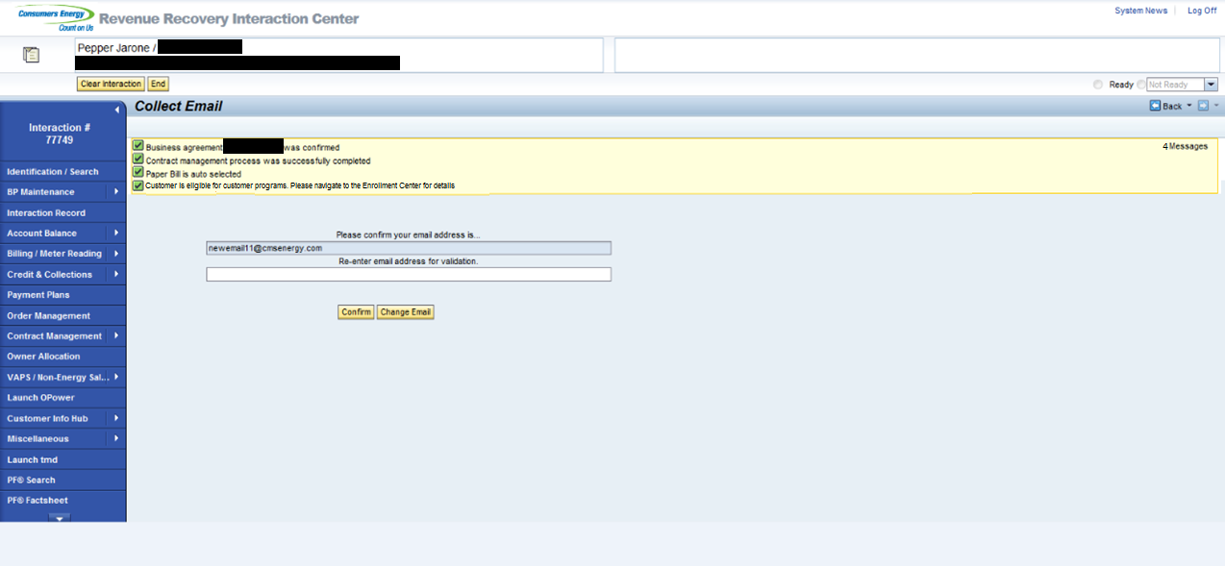

DPP Enrollment Initiation Screen

Once the CE user clicks on “Enroll” in Enrollment Center screen; DPP Enrollment Process starts and a screen comes up to capture the BP communication data (Email, Phone numbers) in SAP which will flow to iFactor using existing two way communication interface.

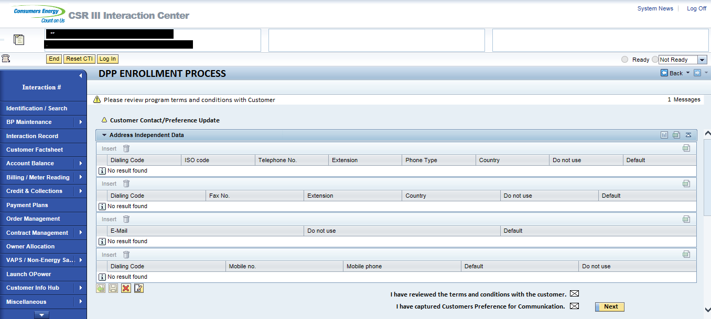

Enrollment Process

Once the CE user completes the enrollment initiation as described above, it will create a new entry in the Enrollment Table (ZTPGM_ENROLL) with a status set to ‘Pending’ and an interaction record will be created (Please Refer to Functional Specification PJT03030.R5.SAP.FS.DPP.ENH.DPP.002.DPP Interaction Records.v0.1). Additionally Preference Center Page will be open in new window to maintain the preferences for DPP.

The entry will remain in the Enrollment table with a Pending status until the associated DPP batch job identifies that the account has gone through billing and is ready to start the next billing cycle. For details please refer to Functional Specification PJT03030.R5.SAP.FS.DPP.REP.DPP.001.DPP Enrollment Completion Batch and Rate Change.v0.1. Once this is identified, the batch job will complete the rate change in ECC. When the rate change is successful, the system will automatically initiate the associated device configuration in background as needed in order to successfully complete the DPP program enrollment as expected (please refer to the DPP Billing Functional Specification for more details of these post-rate change processes). At this time the entry in the enrollment table will be updated to a status of “Enrolled”.

Cancel Enrollment Request

In case customer would like to cancel a previously requested enrollment; customer needs to call the CE and cancel the enrollment. CE CSR will go to the Enrollment Center and initiate the Cancel process. At this time the entry in the enrollment table will be updated to a status of “Cancel”. An interaction record will be created (Please Refer to Functional Specification PJT03030.R5.SAP.FS.DPP.ENH.DPP.002.DPP Interaction Records.v0.1). At this time the cancellation of enrollment will be sent to EV and iFactor. Please refer to Functional Specification PJT03030.R5.SAP.FS.DPP.INT.DPP.005.Enrollment and De-Enrollment confirmation to DRMS.v1.0.

De-Enrollment Process

In case a customer is already enrolled in DPP program and request CE to be removed from DPP Program. CS CSR will perform de-enrollment from Enrollment Center by clicking on De-Enroll button. Once a De-Enroll button is clicked system will perform the de-enrollment immediately by changing the status from Enrolled to De-Enroll. A background process will start the rate change process in the background. Please refer to Functional Specification PJT03030.R5.SAP.FS.DPP.ENH.DPP.008.De-Enrollment Process.v.01 for details. The de-enrolment will be sent to EV, iFactor and DRMS using the interface PJT03030.R5.SAP.FS.DPP.INT.DPP.005.Enrollment and De-enrollment confirmation to DRMS.v1.0

Upon completion of move-out process the de-enrollment will be initiated automatically. Please refer to Functional Specification PJT03030.R5.SAP.FS.DPP.ENH.DPP.008.De-Enrollment Process.v.01 for details. The de-enrolment will be sent to EV, iFactor and DRMS using the interface PJT03030.R5.SAP.FS.DPP.INT.DPP.005.Enrollment and De-enrollment confirmation to DRMS.v1.0

New Move-In Process

In case previous customer was enrolled in DPP; during the Move-In process for same premise CE CSR will have to change the Product from RS_1007 or RS_1008 to RS_1000 manually. If the new customer wants to participate in DPP; CE CSR need to follow the enrollment process as described above via Enrollment Center.

Move-Out Reversal Process

In case DPP enrolled customer request move-out reversal; CE user need to reverse the move-out and make sure the rate is RS_1007 or RS_1008. System will update the status “De-Enroll Cancel” in Enrollment Table (ZTPGM_ENROLL). The de-enrolment cancel will be sent to EV, iFactor and DRMS using the interface PJT03030.R5.SAP.FS.DPP.INT.DPP.005.Enrollment and De-enrollment confirmation to DRMS.v1.0.

Once DRMS sends back the confirmation; system will update the enrollment table (ZTPGM_ENROLL) to status “Enroll”.

Move-In Reversal Process

In case Move-In reversal is required for the customer with “Pending” enrollment in DPP will follow the same process as cancelling the Pending enrollment.

In case Move-In reversal is required for the customer with “Enroll” status in DPP program, will follow same process as De-Enrollment.

Following is the Customer Program Product change matrix.

Custom Class
None Identified.

Standard Rule
None Identified.

Custom Table Creation
None Identified.

Work Item Delivery Requirements
None Identified.

Triggering Events Determination
None identified

Escalation Requirements
None Identified.

Dependencies
All other DPP Enrollment specs are dependencies in order for the functionality listed above to work as expected.

Error Handling Method
None Identified.

Post Execution Notification Details
None Identified.

Process Log Details
None Identified.

Other
None Identified.

Unit Test Plan

Information Security
None Identified.

Information Classification
None Identified.

Security Roles (Profiles and Authorizations)
None Identified.

Table Security (if applicable)
None Identified.

ABAP Program Security (if applicable)
None Identified.

Audit
None Identified.

Questions / Issues / Risks
None Identified.

